**Product Recall:  
QuickStand Lite**

Humanscale Corporation is voluntarily executing a program to replace all Dynamic Arm Long parts of the QuickStand Lite Workstation product (see image below) sold or distributed during the period of January 2015 through November 2018. The M8 Dynamic Long Arm can fail, which can cause the workstation to fall and pose a risk of injury to someone at or near the unit.

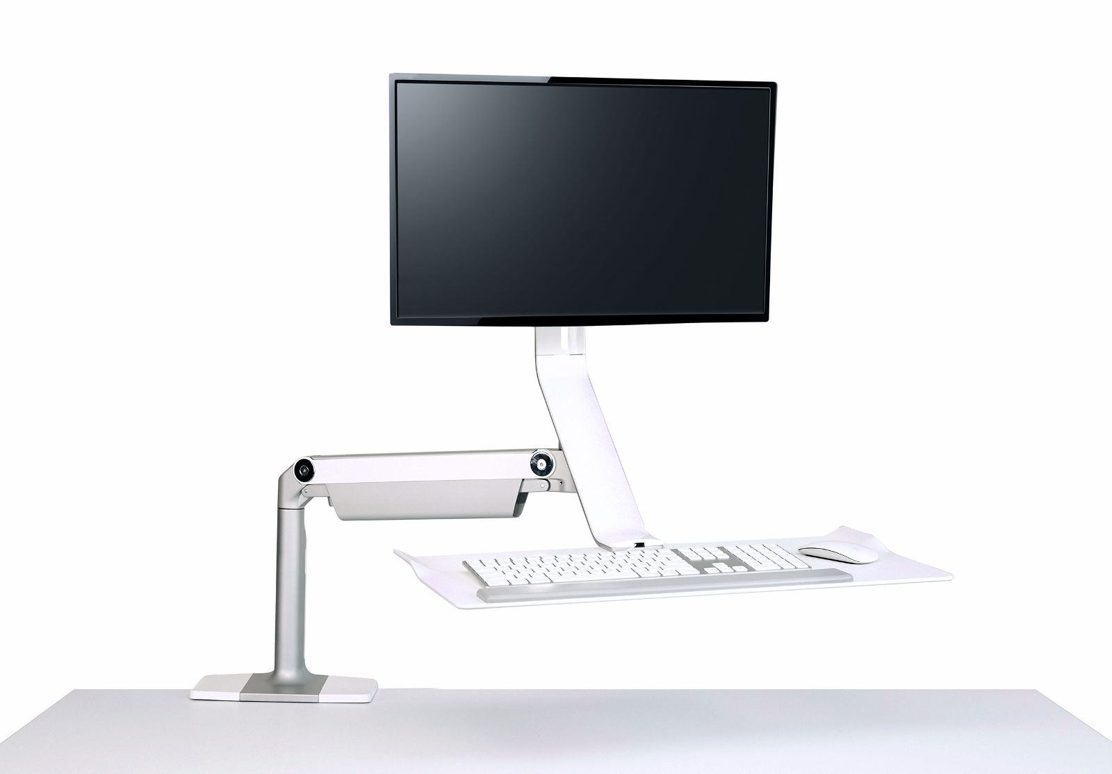

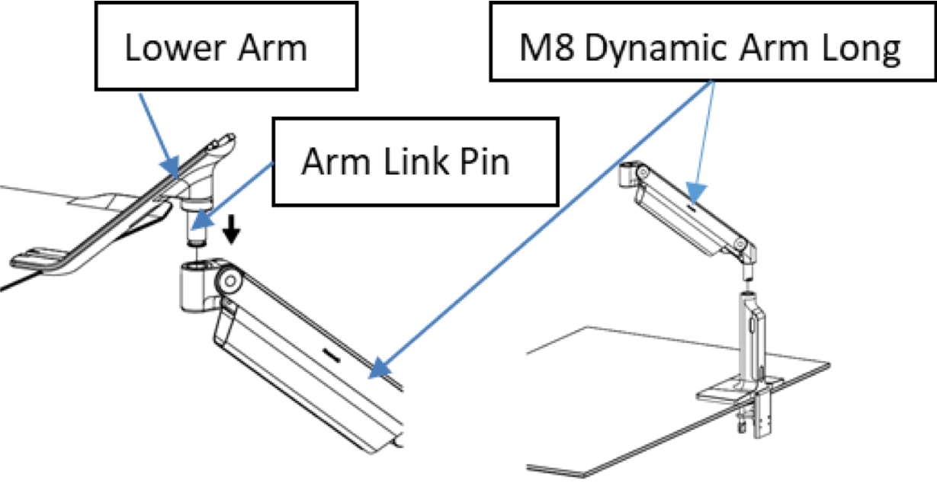

Please immediately contact Humanscale to receive a free Replacement Kit along with installation instructions. You can call Humanscale toll-free at 855-319-0315 from 8 a.m. to 5 p.m. EST Monday to Friday or email at [**QSLinquiry@humanscale.com**](mailto:QSLinquiry@humanscale.com).

[**Read the instructions**](https://humanscale.getbynder.com/m/5609ee80cf8070b5/original/QSL-Repair-Instructions.pdf) or watch how to properly install the Dynamic Arm Long

Please have the following information ready to ensure the properly sending information for the Replacement Kit:

* Number of Replacement Kits needed
* Address where the replacement kits should be sent

We apologize for any inconvenience this may cause and thank you very much for your prompt attention to this replacement. Humanscale takes the health and well-being of our customers seriously and is taking proactive steps to ensure your safety.

Please go to the following site for video instructions for the repair:

[***https://ca.humanscale.com/about/legal-information/product-recall.cfm***](https://ca.humanscale.com/about/legal-information/product-recall.cfm)

***Gov’t of Canada Recalls and Safety Alerts (English):*** [***http://healthycanadians.gc.ca/recall-alert-rappel-avis/hc-sc/2019/70969r-eng.php***](http://healthycanadians.gc.ca/recall-alert-rappel-avis/hc-sc/2019/70969r-eng.php)

***Gov’t of Canada Recalls and Safety Alerts (French):*** [***http://canadiensensante.gc.ca/recall-alert-rappel-avis/hc-sc/2019/70969r-fra.php***](http://canadiensensante.gc.ca/recall-alert-rappel-avis/hc-sc/2019/70969r-fra.php)